Electroencephalography is a
A. Diagnostic test for CVD
B. Diagnostic test for nervous disorders
C. Diagnostic test for renal failure
D. Diagnostic test for liver
ANSWER: B
EEG stands for
A. electroencephalogram
B. computerized tomography
C. Magnetic resonance imaging
D. None of these
ANSWER: A
CT scan stands for
A. electroencephalogram
B. computerized tomography
C. Magnetic resonance imaging
D. None of these
ANSWER: B
MRI scan stands for
A. electroencephalogram
B. computerized tomography
C. Magnetic resonance imaging
D. None of these
ANSWER: C
________ is a test that measures electrical activity in the brain using small, metal discs (electrodes) attached to the scalp
A. electroencephalogram
B. computerized tomography
C. Magnetic resonance imaging
D. None of these
ANSWER: A
_________scanners use strong magnetic fields, magnetic field gradients, and radio waves to generate images of the organs in the body
A. electroencephalogram
B. computerized tomography
C. Magnetic resonance imaging
D. None of these
ANSWER: C
A ___________ is a medical imaging technique used to obtain detailed internal images of the body
A. electroencephalogram
B. computerized tomography
C. Magnetic resonance imaging
D. None of these
ANSWER: B
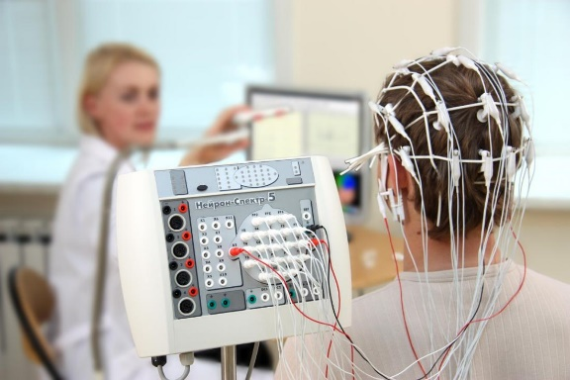
The diagram represents which of the following test?
A. electroencephalogram
B. computerized tomography
C. Magnetic resonance imaging
D. None of these
ANSWER: A
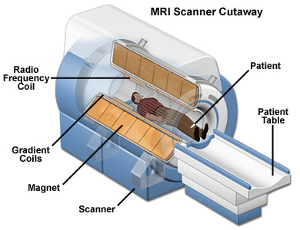
The diagram is of:
A. electroencephalogram
B. CT scanner
C. MRI scanner
D. None of these
ANSWER: C
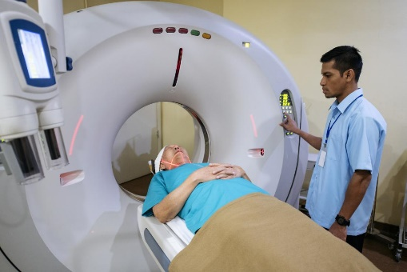
The diagram is of:
A. electroencephalogram
B. CT scanner
C. MRI scanner
D. None of these
ANSWER: B
________use a rotating X-ray tube and a row of detectors placed in a gantry to measure X-ray attenuations by different tissues inside the body
A. electroencephalogram
B. CT scanner
C. MRI scanner
D. None of these
ANSWER: B
__________use strong magnetic fields, magnetic field gradients, and radio waves to generate images of the organs in the body
A. electroencephalogram
B. CT scanner
C. MRI scanner
D. None of these
ANSWER: C
Neurons within the cerebral cortex continuously generate electrical activity
A. coronary artery
B. Nephrons
C. Neurons
D. None of these
ANSWER: C
An EEG pattern is commonly called
A. electrical signals
B. brain waves
C. waves
D. CT
ANSWER: B
CT scan is used to:
A. define normal structure in the body
B. abnormal structure in the body
C. assist in procedures by helping to accurately guide the placement of instruments of treatments
D. All of these
ANSWER: D

